**Computation Vision FS18**

**Visual pathways**

The fovea has a very high density of cones and no rods. It is this structure, which is involved in looking when we point our view at something. The density of cones decreases as we move away from the fovea. The optic disk (15° - 20°) has no photoreceptors, since all the nerves (axons of ganglion cells) converge there. This is commonly known as the blind spot. Rods occur in increasing density the farther away one moves from the fovea. The density of cones decreases rapidly the farther away one moves from the fovea (already before +/- 20 deg there are nearly no cones left). Rods are more abundant than cones in the periphery and they increase even till +/- 20 deg. Then, they very rapidly drop in numbers, since cones are predominant there (at fovea, no rods, also at blind spot, there are neither cones nor rods).

The eye has an inside out structure: The most inner layer is made up of photoreceptor cells. Due to their higher energy demand, they can be supplied with it easier since they are nearer to the arteries. Then, horizontal cells, bipolar cells, amacrine cells, ganglion cells. Ganglion cells are at the outermost layer (if we look into someone’s eyes, we are looking at their ganglion cells).

Types of noise during transmission (inside-out): photon noise, transduction noise, channel noise, synaptic noise, channel noise, synaptic noise (channel noise – bipolar cells), dendritic morphology, spike generator.

General pathway of phototransduction: Eye, photoreceptors, ganglion cells, optic nerve convergence, LGN, V1, higher cortical areas.

**Lateral geniculate nucleus**: The LGN is made up of 6 layers: outer layers: 4 parvo layers; inner layers: 2 magno layers. The LGN has small layers in between: konio layers which are responsible for receiving input from S cones. The layers are: C, IPS, C, IPS, IPS, C. The receptive field of LGN neurons is similar to the RF of retinal ganglion cells suggesting that the retinotopy is presevered pointwise.

**Where and What pathways**: The visual cortex and other corical areas are involved in the recognition of the kind of object (what-pathway) and their spatial relative location (where-pathway).

Brain areas of what-pathway: V1-4, VOT, PIT, CIT, AIT, STP. (ventral stream)  
Brain areas of where-pathway: PIP, MT, MIP, MDP, FST, MST, LIP, VIP. (dorsal stream)

Depending on the lesion site, one can develop visual agnosia (the inability to recognize objects – what-pathway) or they cannot discriminate landmarks anymore (where-pathway).

Other conditions: neglect: cannot make sense of spatial (own body or external) organization of hemifield (visual field) or other parts of the body (parietal cortex lesioned).  
Capgvas syndrome: emotional connection to sensory input disconnected.

V1-4 are spatially located on the surface of the back of our head. Since the brain has many folds, some part of V1-4 extends into the brain due to folding in the so called calcarine sulcus. The striate cortex (visual cortex) is a darkish band in anatomical pictures.

V1 has many connections to V2. Both have a lot of connections to V4. Area IT (=: AIT) is responsible for the perception of objects and faces. Several groups of cells together perceive a distinct object.

**Receptive field (=: RF)**: The number of photoreceptors that feed their information to another cell. Ganglion cells normally have many photoreceptors that connect to it. In the middle, the photoreceptors made up the ON center (depolarization – activation – when light is perceived), while the surrounding cells made up the OFF center (depolarization when no light is being perceived). The RF of a photoreceptor is the photoreceptor itself. In the V1, the RF is monocular. The RF in the LGN is binocular, the ganglion cells basically project 1-to-1. A smaller RF gives a higher resolution of an image (think of it as a filter).

In the V1, most cells are direction or orientation (angle) selective. Most cells are insensitive to spatial information (about 80%) though.

The size of an RF determines the sharpness of perception. It can be thought of as a filter: If the RF is big, then the edges will become blurry, while when the RF is very small the edges are much sharper.

**Rods and cones**: Rods dominate in low light conditions (night vision). Rods cannot perceive light, only contrast. 5-7 photons are enough to have active vision. Every single photon is recorded in the photoreceptors (extremely sensitive). Cones dominate in high light conditions (day vision). They perceive different wavelengths. There are 3 types of cones (S, M, L) that perceive best for short, mid and long-range wavelengths. The graph is a parabola, so even if the exact wavelength is not perceived (S has peak in about 420 nm for example) the wavelength will still be perceived well if it is close to the peak. Increasing light intensity can compensate.

**The principle of univariance**: One photoreceptor is excitable through different wavelengths and intensities. One single photoreceptor cannot therefore differentiate between a change in wavelength or a change in intensity. Thus, the photoreceptors do not pass on unique colour information to the brain. Only by comparing different inputs can the brain interpret colour. So, the light intensity is a physical measure that does not take wavelength composition into account – we can have the same light intensity with different compositions of wavelengths (thus, a photoreceptor never knows which wavelengths stimulated it). **Side note**: Illumination is a rather loose term for wavelength composition.

**Light and dark adaptation**: The photoreceptors are insensible to the absolute value of light intensity. Rather, they adapt on changes in contrast in the environment (this is indirectly the adaption of relative reflected light intensities from the background). Object recognition happens on almost all levels of light intensity, so the actual magnitude of light intensity is not important; the local contrast is what the retina signals to the brain.

In light adaptation, rods first adapt until they cannot respond to changes anymore, then cones take over and adapt accordingly to contrast levels. In dark adaptation, cones adapt until they reach a level where they cannot adapt anymore. Then, rods take over. After around 40 mins, the maximum level of adaptation in the dark has been reached.

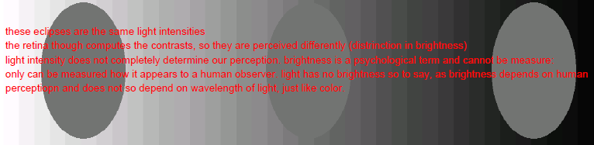

**Mathematical modelling: The linear model**

A ganglion cell can be modelled as a linear model. Specifically, as a “difference of Gaussians”. The ON center has a higher peak and it tails are smaller while the OFF center has a smaller peak, but its tail is 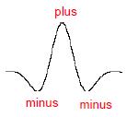longer. Substracting ON – OFF will give a Gaussian with a high peak (maximum) and two negative peaks at the tails (minima).

The response is the product of light intensity and filter (convolution):



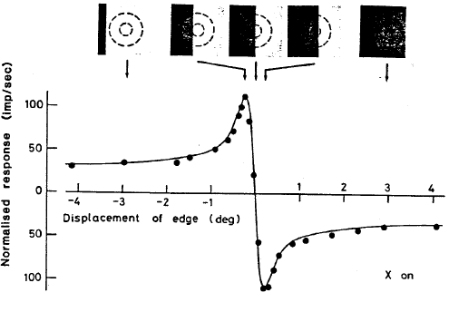In extreme cases, ganglion cells cannot be modelled as a linear system, because eventually they saturate. To characterize a ganglion cell (or an RF) as a linear system, one gives a sinusoidal as input, since the response R(x,y) of a sinusoidal is a sinusoidal and the dependence of response on stimulus frequency can be predicted from the shape of the receptive field. The frequency of initial input remains the same, but amplitude and phase change.

A sinusoidal in the spatial domain looks like a wave of changing light intensity (white-greyish-black-greyish-white-…).

Ganglion cells do no respond as squares to edges. They have curves, where the edge is.

**Chevreuil illusion – Mach bands**: A picture with bands of different grey colours. At the sides of the transition from one band to another, there will be a small slightly darker band (looks like an aura). The brain knows whether the input came from an ON or OFF center.

In the previous two examples, it is always about computing local contrast depending on its surrounding. The brain interprets certain spots to be darker compared to the spots right next to it, because of the way the receptive field of ganglion cells (and probably also V1) is structured (center+surround). If one overlaps it correctly with the test picture, one can produce these phenomena.

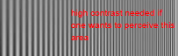**Spatial frequency sensitivity**: If frequency of a sinusoidal in space is high (many sinusoidals next to each other), then the contrast has increase as well if one was to distinguish them. Otherwise they will be perceived as a greyish band (the discrete sinusoidals cannot be perceived anymore due to resolution limits in the retina). Ganglion cells are most sensitive for 1 cycles/deg. Soon after, there is a sharp drop. Cortical cells are sensitive for different cycles/deg. They have highest contrast sensitivity between 3 – 10 cycles/deg. In order to perceive very high spatial frequencies, one needs increasingly higher contrasts (> ca. 20 cycles/deg). If contrast too low, grey is perceived.

**The RF of LGN and V1 simple cells**: The V1 simple cells have amongst others the function to detect lines or bars. Thus, they respond strongly to edges of objects. Moreover, their RF can be circular, elliptical, parallel or elliptical (divided). The ON and OFF regions are separated in simple cells in the V1. Retinal ganglion cells and cells of the LGN are circular, therefore they are incapable of feeding the brain with orientation of a bar. Simple cells are orientation selective thanks to the nature of their RF. Since they receive input from several LGN neurons, their RF is elongated.

Several LGN cells feed into one simple cell. The simple cell is activated if and only if the LGN cells of a certain group/orientation (this can be a column) feed into the simple cell at the same time (AP in all these cells). Therefore, the simple cells in the V1 are highly orientation selective. Note that the RF of LGN neurons is circular.

There are complex cells in the V1 whose ON and OFF regions overlap. A complex cell receives input from both the simple cells in the V1 and from LGN cells. The RF need not be of the same kind, they can have opposite responses for a given stimuli. Thus, a complex cell inherits all their RF.

**Cortical magnification**: The number of neurons in the visual cortex that process a certain stimulus at a certain location in the retina. At the fovea, many neurons dedicate to the processing of a stimulus of a small area. The number of neurons for processing of a stimulus decreases peripherally.

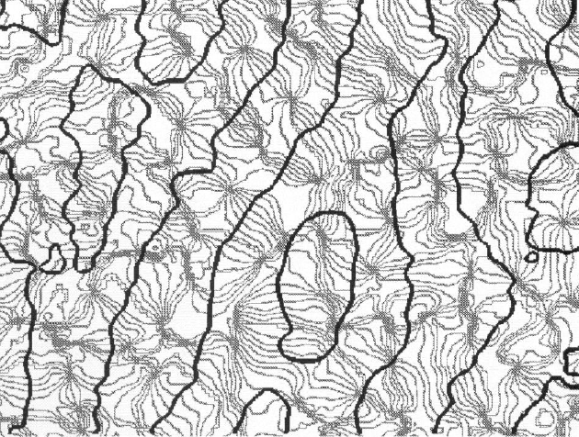**The ice-cube model**: A working model for the primate cortex regarding vision analysis. There are columns for left and right sensory eye input in an alternating fashion (L-R-L-R-…). Each column is divided into blocks with a preference for a specific orientation. This model unifies ocular dominance and orientation selection (resp. orientation preference). In reality, the cortex is not divided in such an orderly fashion.

Grey = orientation border lines.  
Black = ocular dominance borders.

Grey and black lines meet perpendicularly. Grey lines meet converge and meet in the center of an area. So, an area enclosed by a black line is always either L or R. Grey lines represent a certain orientation selectivity.

**The linear model of V1 simple cells**: Thanks to linearity, the RF defines the activity of a V1 simple cell directly and controls its firing behaviour. Mathematically, the frequency is preserved, but amplitude and phase may change.

When the object is aligned with the RF optimally with the right orientation, there will be a lot of firing. If there are too many bands on the RF (the RF is too big for the object), there is a small response, since the bands cancel each other out. Same with few large bands (RF is too small); there is also a small response. If the orientation of the object does not conform to the orientation selectivity of the RF a small response will be the resultant due to cancelling each other out.

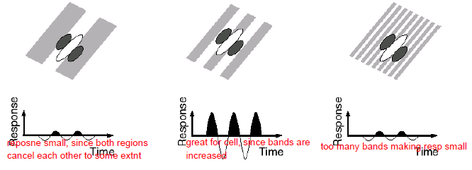

The response of a V1 simple cell can be predict with sine waves. One needs to make further assumptions to model the biological reality faithfully: There are no negative values for a simple cell (threshold). In darkness or during a period of constant firing, d(input)/dt = 0 holds true. Spontaneous firing rate of simple cells is 0.

The spatial frequency domain only informs about the preferred spatial frequency (peak is the most preferred one). Frequency domain = convolve sine wave gratings at different spatial frequencies with the RF map.

Firing behaviour(simple cell) = brr-nothing-brr-nothing-brr-…  
Firing behaviour(complex cell) = brr-brr-brr-brr-… (frequency of firing can also be doubled and a few other conceivable cases exist due to their non-linear nature).

**V1 non-linearities**

Basic non-linearity (also true for linear V1 simple cells): thresholding.

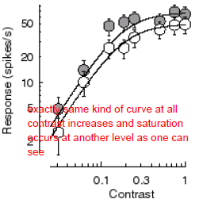**Violation of homogeneity: Saturation**

The response (spikes/s) gradually saturates (becomes smaller) as the contrast increases (the response curve flattens as contrast approaches 1). Thus, the difference between predicted and observed firing becomes smaller as contrast increases. Saturation depends on contrast.

Also, if orientation of object is not optimal, the response (y-axis) will be smaller (below optimal response), but saturation will occur in the exact same manner based on contrast as in the optimal case (saturation-contrast phenomenon could be linear).

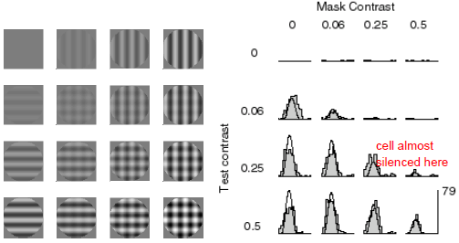**Violation of superposition: Masking**

Masking: overlaying objects, such that destructive inference occurs for example. Thus, an object with optimal response for a given RF of a complex cell is overlaid with another object with very weak response. Very small contrasts almost show no difference (also when overlaid). As the contrast increases, the response will be smaller (at some non-intuitive cases, the cell can even be silenced). It is not the sum though, it is less.

**Non-linear model of V1 simple cells**: The input of a V1 simple cell is divided by its neighbouring cells in its vicinity. The simple cell has an optimal firing response with regard to orientation selectivity. The cells in its vicinity also generate an AP, but it is slightly different, due to a slightly different orientation selectivity. Their output will feed into the first V1 simple cell in an inhibitory fashion. Therefore, the final output of the first V1 simple cell is lower than expected.

Inhibitory simple cells do not activate at low contrast levels when there is suboptimal stimulus.

**Non-linearity: Adaptation**

Adaptation influences V1 neuron sensitivity. When adaptation contrast is very low, no adaptation occurs (control situation during an experiment). At higher adaptation contrasts (e.g. 50%), looking at the object/picture will lower the response during the test phase. Also, if adaptation contrast was a lot higher than test contrast, there will be basically no activation of V1 neurons.

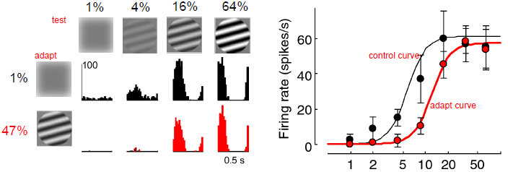  
Waterfall illusion: looking at a rotating object (always same direction) for some time and then looking away makes you see the object rotating in the other direction due to adaptation. In case of waterfalls, you see the waterfall falling upwards when you look away.

**Non-linearity: (Hebbian) learning**

Basically, LTP during visual conditioning. Before conditioning, a circuit has a preferred orientation and motion of an object (e.g. bar). The circuit is plastic, therefore when exposure to a different orientation occurs long enough, LTP will strengthen other synapses in the circuit, such that the circuit gains a new preferred orientation and motion of a bar (to some extent – permament of a circuit is conceivable, conditioning would need to be during a really long constant period, such that LTP can actually rewire the circuit and weaken the previous circuit considerably). After a recovery phase (grey screen in experiments), the initial preferred orientation and motion of bar is restored mostly (not completely). This is because LTP cannot induce immediate constant changes during typical (short) experimental time windows.

**Depth perception**

**Monocular depth cues (only one eye needed)**: lighting and shadows, perspective, interposition, size, clarity and evaluation, shade cues. Shade cues are quite sophisticated: Experientially, light comes from above. Objects that are brighter on the to than on the bottom will tend to stick out, while the same object seems to be a hole when the top is darker than the bottom.

**Binocular depth cues (two eyes needed)**: convergence, stereopsis (binocular disparity).

**Convergence**: This binocular cue provides the observer with angle information of an object. That way, the distance of an object to the observer can be approximated (absolute distance, assume observer is at (0/0/0)). This cue does not work so well in the darkness, but it becomes somewhat easier to approximate the distance if the object moves in the dark.

**Binocular disparity**: This cue provides the observer with relative depth. The fixation point fall on the fovea. Objects closer than the FP will fall more temporally on the retina (more on the left side of the left eye, vice versa for right eye). Objects farther away than the FP will fall more nasally on the retina. From experience, we will interpret objects falling nasally on both retinas as far, while we interpret objects falling on the temporal side of both retinas as near. It goes without saying that such objects will be seen double, since we do not have any neurons that can connect both inputs from the retinas as a single picture (unlike the FP).

The **horopter** is a line on which objects have the same absolute distance as the FP (basically, a circle with the observer in the middle). All objects will be interpreted at the same depth as the FP, since there are cells that combine both pictures of the retina even if they are not on the retina. This is the case when an object falls on the same side of the retinas (both are on the right or on the left of both retinas. Aliter: the object falls on the nasal side of one retina and on the temporal side of the other).

**Panum’s fusion area** is basically the extension of the horopter. Even if not all objects lie on the horopter, they can still be fused into one picture as long as they are in the area (assumption: there are binocular cells, that can combine both inputs, because they are “close enough” on the retinas). Outside Panum’s fusion area, we see diplopic.

**The Wheatstone stereoscope**: Precursor of 3D cinema. Two projects of an image with a very small difference are projected on two mirrors (back to back with a certain angle, so that we can see both simultaneously). Observer is at a distance d from the mirrors, such that Panum’s fusion area take effect.

There is a fundamental correspondence problem in making use of the stereopsis cue. Points of different relative lengths from each other, fall in the same manner on the retina.

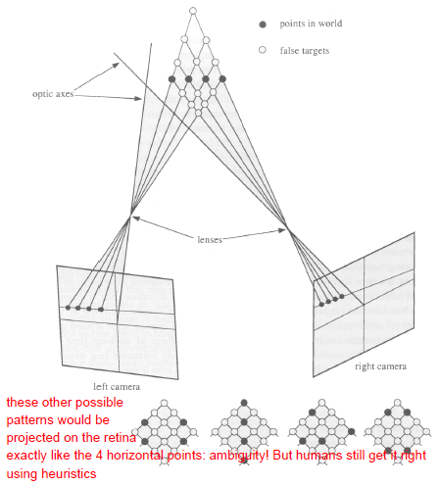

There are neurons tuned for binocular disparity in the V1. There are cells that are excited by positive disparity, are inhibited by small disparity (and excited by bigger disparities), are nearly completely inhibited by near objects (negative disparity), but very active by faraway objects or are excited by near objects and inhibited by faraway objects.

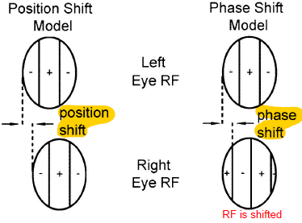It is: disparity = 0 ⬄ object falls on fovea, negative disparity = object falls temporally on retina, positive disparity = object falls nasally on retina.

How can we obtain a peak at non-zero? There position and phase shift model both occur in the brain:

**Position shift model**: Consider a binocular neuron, whose right subfield is shifted by a certain distance, when compared to the left subfield (this means: left subfield has distance d from fovea, while right subfield has distance d+s from fovea).

**Phase shift model**: Consider a binocular neuron, whose subfields are centered at the same retinal position, but their RF are differently shaped. Thus, we have a phase shift in one of the RF when compared to the other.

**Colour Vision**

Evolutionary, colour vision is important for distinguishing healthy, foul, toxic fruits in the forest better. Also, identification of fruits and other smaller objects in nature is enhanced when compared to non-colour vision. On the other hand, some animals lost their third type of photoreceptors due to predominant night activity (enhanced night vision). Nowadays, colour vision is not needed for most daily activities.

A single photoreceptor does not pass on unique colour information (see principle of univariance). The analysis of higher visual areas of several inputs ultimately generates colour vision.

**Levels of colour processing**: photoreceptors:primaries, LGN:opponent colours (red/green, blue/yellow, black/white), cortical cells:intermediate colours (higher order mechanisms).

**Real life colour vision**: An illumination source emits a certain spectrum with a certain intensity. This hits a surface, which reflects the light source with a certain reflectance. The reflected signal is called the colour signal and it is a function of illumination of the light source and the reflectance of the material. In the eye, the three cone types have different sensitivities for wave lengths and act as a filter. In terms of relative absorptions, L cones > M cones > S cones.

L cones are most sensitive at 564 nm (yellow), M cones at 533 nm (greenish-to-yellowish) and S cones at 437 nm (blue light). Thus, humans are called trichromatic. These three colours are **unique colours**. They are independent of each other (in yellow, there is no trace of neither green nor blue etc.). Another unique colour is red. There are indefinitely many unique colours that satisfy the condition (independence of other colours). Rods have optimal absorbance at 498 nm, but they are not involved in colour vision. During day light, they are the first to saturate. One needs at least three unique colours (also called **primaries**) to generate all other colours. Also, we need at least two different types of cones to perceive colour at all. If one were to be a monochromatic, no colour perception would be possible.

The cones feed into pLGN cells, while rods feed into magno LGN cells (black/white) which are also involved in perception of movement and depth.

Since the pigment genes are located on the X chromosome, some women have been found to have a 4th pigment (they are called tetrachromatics). This cone is between M and L cones. These individuals are capable of perceiving slight differences in this colour range (yellow/green), which is not perceived by trichromatics. The molecule responsive for wavelength detection is rhodopsin. It is situated at the most outer segment of photoreceptors and there are 3 different main variants in humans (for each cone, there is a slightly different rhodopsin molecule). Rhodopsin is also different amongst different species and even in individuals of the same species due to mutation and adaption of its environment.

Colour is not a physical property of an object (only the wavelength is). What is casually referred as colour is often the hue (dt. Farbton). Colour is hue + saturation (amount of white light in a hue) + other factors (also cognitive factors (psychophysics): a banana will appear more yellow than another object with same reflected wavelength due to our experience and expectation).

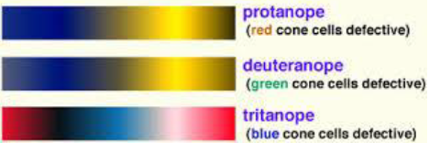**Colour blindness**: Protanope: red cones defective => mainly blue and yellow vision.  
Deuteranope: yellow cones defective => mainly blue and yellow vision, slightly shifted than protanope (perceives light blue end better, but dark yellow end worse).  
Tritanope: blue cones defective => mainly red and blue vision. A light blue can still be generated.

Colour blindness is more prevalent in men than women due to X chromosome linkage. Prevalence for men is 10%.

Not all colour vision problems are due to photoreceptors and pigments. Some colour blindness occurs in the temporal pathways (higher cortical brain areas). This condition is called **cerebral achromatoxia**.

**Cone mosaics**

Density and abundance of cone types is heterogenous and even different in individuals. At the fovea, there are no S cones (blue light). Most abundant cone type are L cones (for some people, M cones might occur at a higher ratio in the retina or at some places of it). At the center of the fovea, we are therefore dichromatic (no S cones). This area is mainly occupied with maximizing resolution.

The ratio of cone types is not relevant for actual colour vision, since all humans see colours as long as the abundance of a cone type reaches a threshold minimum

**Colour matching experiments** do not allow us to predict how a colour looks like. But if we know the cones of a subject, we know what it will perceive in terms of colour. Nonlinearities include adaptation (looking too long at red will give us a red impression for some time) and other wavelengths that play a role (interference).

**Setup**: Subject perceives colour with known wavelength, saturation etc. He then matches the colour on a screen (the screen changes its colour, when the subject sets different parameters). Predictions are usually really good.

There are LGN neurons whose RF are influenced by colour: Some RF centers are excited by red light and the surround is inhibited by green light. Some centers are excited by the absence of red light etc.

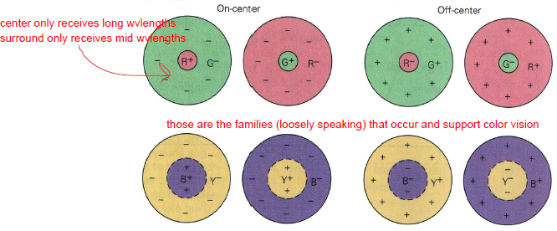

**The DKL colour space**

A spherical colour space that is used to represent colours. 3 axes: Luminance axis (portion of light: if luminance is at +max, then only white colour. If luminance at -max, then dark colour (black)).  
Red-green (L-M) axis: sum of M and L cones is constant. Approaching +90deg gives more M cones than L cones. Approaching -90deg gives more L cones than M cones.  
Blue-yellow (S-(L+M)) axis: Excitation of L+M remains the same along the axis, but we add more or less S cones input. The point of origin is grey. It is based on the excitation of cones.

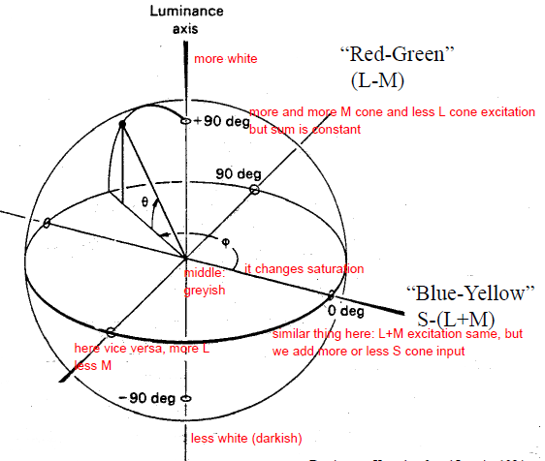

Phi angle = azimuth angle. Theta angle = elevation angle.

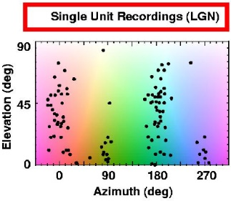Thus, we can plot the preferred colour of parvo LGN neurons and V2/V3 (cortical neurons) in terms of the azimuth phi and the elevation theta. For parvo LGN neurons, we find 2 distinct clusters: a red/green cluster (also contains cells with very high elevation in both “towers” – these cells are mostly concerned with black/white perception, since their saturation (elevation axis) is very high). The second cluster is blue/yellow. There are parvo LGN neurons, which are excited by red in the center of their RF and inhibited by green in their surround or vice verso (see above). Same for the blue/yellow pair. These are the only two pairs. It is in such an orderly fashion, since the parvo LGN neurons only understand primaries. This is not the case anymore for cortical neurons.

Visual input is analysed through 3 different channels. The first channel dedicates its analysis to the light intensity (black/white), the second one to the red/green composition of an object and the last channel to the blue/yellow composition.

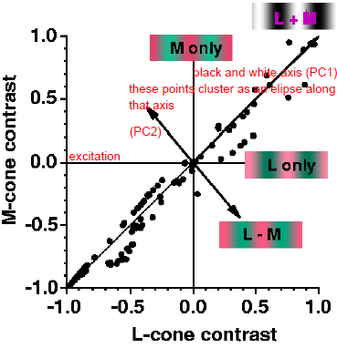Due to the information transmission through a limited capacity channel, information is summarised in that manner (red/green, blue/yellow and black/white pair) in order to remove redundancy due to the evolution of vision perception having natural colour objects as its basis.

**Preferred colours of cortical cells**

Cortical cells differ in two aspects: They do not cluster with regard to preferred colours and their excitation criteria are different due to their complex nature.

Most cortical cells have a preference for non-primaries (intermediate colours). The distribution is rather uniform and since most of them have a high elevation, they are more interested in light intensities. In the cortex, cortical cells respond best to all kinds of colours.

Secondly, cortical cells respond differently to colour variations. This leads to a very high differential selectivity to colours by cortical cells. (not the case in the retina or LGN). Some cells have rectified sine waves as their mathematical representation of their firing behaviour. These are less selective for specific colours, but can respond equally well to different colours. Other cortical cells are highly selective for one hue (colour). They only have one narrow peak and all other values can be even lower than spontaneous firing.

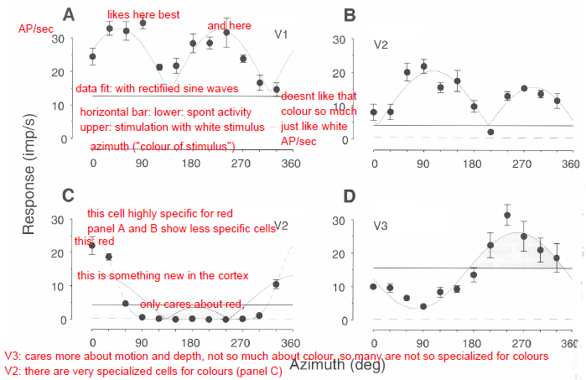

**Colour constancy**

The ability of the brain to produce the same colour independent of illumination. Aliter: the brain is capable of extracting colour information from the light. This information does not rely on the light intensity (illumination). Since wavelengths vary dramatically throughout the day and from different light sources (sun, light bulb, candle, artificial light, sunset, sunrise etc.) light intensities and wavelength composition differs greatly. In spite of that, the brain represents for example the green of a leaf nearly always the same under all conditions. Thus, colour constancy stands for the invariance of colour representation under different light intensities and wavelengths (to a certain extent). The exact mechanisms are still unknown (involved psychophysical factors).

Colour constancy is subject to many illusions: The same red (hue) is interpreted slightly differently when there is either blue or yellow in its close proximity.

One can put a colour filter (e.g. cyan) over one half of a grey picture of a girl. Even though both eyes are grey, our brain will interpret one eye as yellow because of colour constancy.

Exam: no trick questions that play with language. Usually, our first interpretation should be the right one, but we can also write down our interpretation, so Kiper can read it and correct our answers accordingly. Don’t overinterpret the statements.

Questions from Q&A session:

How do photoreceptors and rods adapt? Yes, they adapt. How? No one really knows as of now. Most mechanisms of adaptation have to do with biochemical reactions with the outer segments when capturing photons. These cascades are affected by Ca2+ (when Ca2+ enters photoreceptor affecting cascade and change in membrane potential) and other factors. Basically, the entry of different compounds. **Not important for this class**.

Model of perceptual sensitivity: how sensitivity of **individual cortical cells** is related to overall contrast. The hills are most sensitive at their maximum: go down and read the cycles per sec (the higher cycles per sec, the narrower the lines are). There is a sharp drop after 30 deg.

Hierarchies: example: V4 receives feedforward input from V2 and gives feedback output to V2. V2 cells have axons that end in V4. V4 has cells that project in V2 back. So, V4 is at a higher hierarchy than V2.

Third pdf (retinal pathways 2): “Questions for next week”:

Simple cells have elongated ON and OFF centers, since they get input from LGN cells, whose centers are circular and therefore, the centers of simple cells is elongated (the sum of LGN cells, looks like a sausage).

1. There is input that is aligned with several LGN, that fire together under some circumstances. Thus, a V1 simple cell is orientation selective.
2. Complex cells receive input from different LGN cells and from simple cells (mainly simple cells, simple cells get input from different LGN cells). If simple cells have superimposed RF, then complex cells have a RF that has + and – at the same time (no clear ON or OFF regions).
3. Yes. The stimulus can be perfectly matched. When it is a bit changed, it will not respond so well anymore, therefore it is very orientation and spatial frequency selective. Simple cells have elongated subfields. A simple cell by definition has non-overlapping ON and OFF fields.

Correspondence problem: if there are no further assumptions, we cannot really know what the right configuration of the lights is. We will simply interpret them all at same depth (basically all next to each other). In real life situations, we get such situations right using heuristics (using assumptions).

Colour vision with PC: There is a high correlation. If L cone activated, then M cone also somewhat activated, due to very similar pigments.

In the retina, the cells before the photoreceptors are transparent. In the fovea, they are sort of pushed to the side, so photoreceptors are basically exposed.

The cones first evolved. Rods evolved out of cones. The main molecules involved in vision at the level of photoreceptors is rod or cone opsin and rhodopsin. The cascade involves GPCRs. Rods are more sensitive as they detect single photon changes.